**PROJECT REPORT OF**

**DIGITAL SIGNAL PROCESSING**



**Project Title:**

**WORD RECOGNITION**

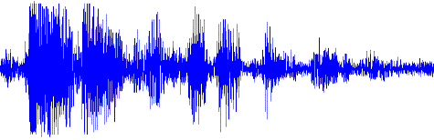

**Group Members: Roll No.:**

1. M.Ali Shaikh 2017-TE-027
2. M.Arsalan Mirza 2017-TE-028
3. Abdul Quyyum Qureshi 2017-TE-036

**SUBMITTED TO: SIR IRFAN USMANI**

**WORD RECOGNITION**

The speech is primary mode of communication among human being and also the most natural and efficient form of exchanging information among human in speech. So, it is only logical that the next technological development to be natural language speech recognition. Speech Recognition can be defined as the process of converting speech signal to a sequence of words by means Algorithm implemented as a computer program. Speech processing is one of the exciting areas of signal processing. The goal of speech recognition area is to developed technique and system to developed for speech input to machine based on major advanced in statically modeling of speech ,automatic speech recognition today find widespread application in task that require human machine interface such as automatic call processing.

Speech Recognition (is also known as Automatic Speech Recognition (ASR) or computer speech recognition) is the process of converting a speech signal to a sequence of words, by means of an algorithm implemented as a computer program. Speech recognition is used in almost every security project where you need to speak and tell your password to computer and is also used for automation. For example, I want to turn my AC on or off using voice commands then I have to use Speech Recognition. I have to make the system recognize that whether I am saying ON or OFF. In short, speech recognition plays a vital role in voice control projects. In today’s post, I am goanna show you How to do Speech Recognition in [Matlab](https://www.theengineeringprojects.com/2016/02/matlab-projects.html) and the technique I have used in this project is known as cross correlation. You should also have a look at [Eye Ball Detection in MATLAB](https://www.theengineeringprojects.com/2017/03/eye-ball-detection-matlab.html).

Correlation is normally used in signal processing , where you need to compare two signals and need to find the similarity between them. It is also known as the dot product of those two signals. Correlation has many uses and you can read more about it on its [Wiki Page](https://en.wikipedia.org/wiki/Cross-correlation). Correlation is also used for pattern recognition like you want to find some pattern in the signal then you can use Correlation. Anyways, in our project we are using correlation to find similarity between our stored signals and the testing signal. So, let’s get started with Speech Recognition in MATLAB using Correlation.

**Working**

* First of all, I uploaded the test file which I want to compare with my samples.
* After that I upload all the 6 samples and also get their correlation with the test sample.
* Finally at the end I compared the results and on the basis of it I figured out which one is correct speech file.
* You will also get spectrum graphs of your sound files as shown in below figure:

**Commands used in our project**

* audioread
* xcorr
* length
* max
* if else
* soundsc

**Coding**

function wordrecognizer(filename)

%Word Recognition Using Correlation Method

%Write Following Command On Command Window with desire file name instead of file name

%wordrecognizer('test.wav')

voice=audioread(filename);

x=voice; %voice variable to x variable%

x=x'; %Convert two column to row%

x=x(1,:); %Convert two row and many column to one row & many column%

x=x'; %convert one row & many column in one column & many row%

L=length(x);

t=-((L-1)/2):1:((L-1)/2);

t=t';

subplot(6,1,1);

plot(t,x);

y1=audioread('aalif.wav');

y1=y1';

y1=y1(1,:);

y1=y1';

z1=xcorr(x,y1);

m1=max(z1); %Save Max Amplitude of sequence in m1%

l1=length(z1);

t1=-((l1-1)/2):1:((l1-1)/2);

t1=t1';

subplot(6,1,2);

plot(t1,z1);

y2=audioread('baa.wav');

y2=y2';

y2=y2(1,:);

y2=y2';

z2=xcorr(x,y2);

m2=max(z2);

l2=length(z2);

t2=-((l2-1)/2):1:((l2-1)/2);

t2=t2';

subplot(6,1,3);

plot(t2,z2);

y3=audioread('bee.wav');

y3=y3';

y3=y3(1,:);

y3=y3';

z3=xcorr(x,y3);

m3=max(z3);

l3=length(z3);

t3=-((l3-1)/2):1:((l3-1)/2);

t3=t3';

subplot(6,1,4);

plot(t3,z3);

y4=audioread('dsp.wav');

y4=y4';

y4=y4(1,:);

y4=y4';

z4=xcorr(x,y4);

m4=max(z4);

l4=length(z4);

t4=-((l4-1)/2):1:((l4-1)/2);

t4=t4';

subplot(6,1,5);

plot(t4,z4);

y5=audioread('dsp1.wav');

y5=y5';

y5=y5(1,:);

y5=y5';

z5=xcorr(x,y5);

m5=max(z5);

l5=length(z5);

t5=-((l5-1)/2):1:((l5-1)/2);

t5=t5';

subplot(6,1,6);

plot(t5,z5);

Amp=[m1 m2 m3 m4 m5];

m=max(Amp);

h=audioread('allow.wav.');

L=length(h);

if m<=m1

soundsc(audioread('aalif.wav'),12*L)

soundsc(h,2*L)

elseif m<=m2

soundsc(audioread('baa.wav'),10*L)

soundsc(h,2*L)

end

**OUTPUT**

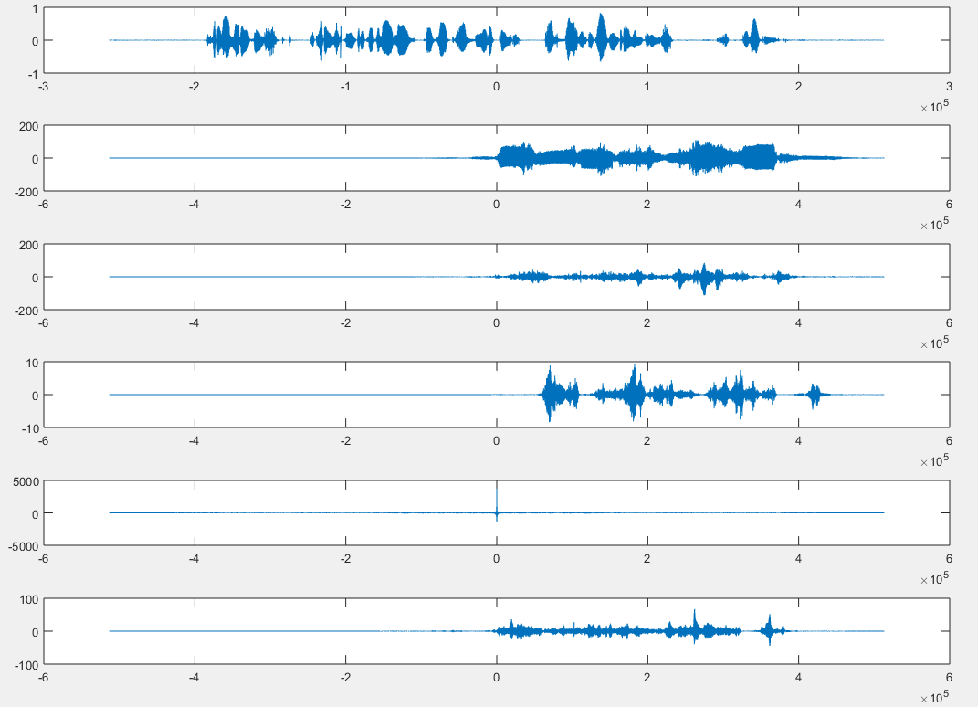

CONCLUSION:-

In this project we recognize different audio speeches or voices with different sampling rate and with different time slots by using correlation on MATLAB and observed graphical presentation of our audio by spectrum.

THANK YOU